Missionaries and Cannibals Problem

AIM:
To write a Python program to solve the Missionaries and Cannibals Problem while ensuring that the missionaries are never outnumbered by cannibals on either bank when missionaries are present.

Algorithm:
- Start the program.
- Initialize the numbers of missionaries and cannibals on both riverbanks.
- Place the boat on the starting bank.
- Generate possible boat movements carrying one or two people.
- Check that no bank has more cannibals than missionaries when missionaries are present.
- Reject invalid or previously visited states.
- Continue until all missionaries and cannibals reach the destination bank safely.
- Display the sequence of valid states.
- Stop the program.
Code :
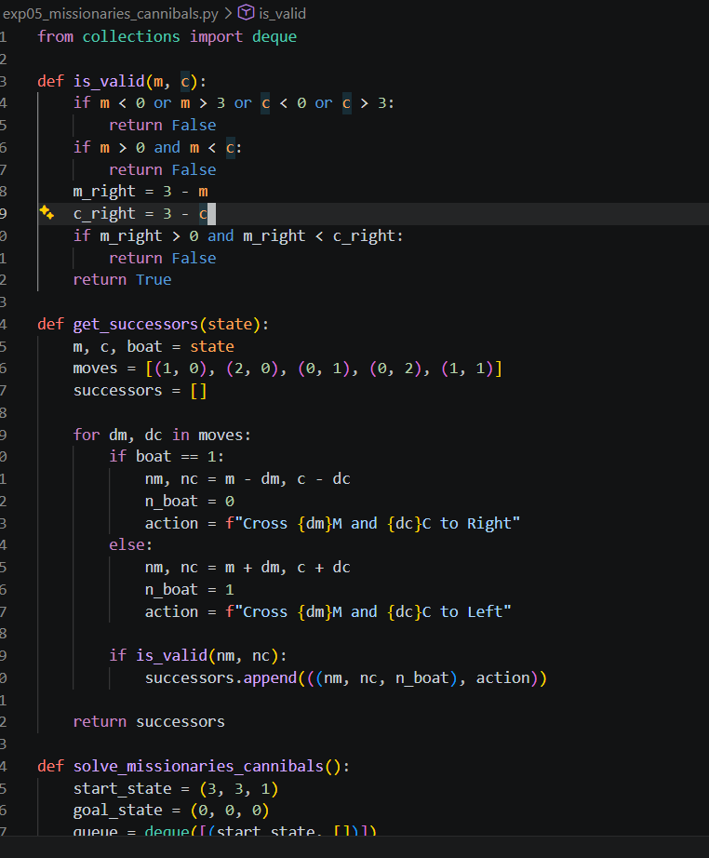
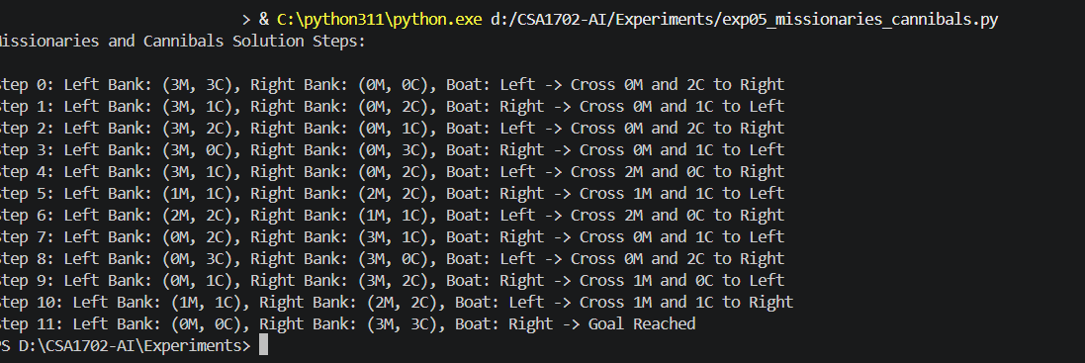
Output :
RESULT: Thus, the Python program to solve the Missionaries and Cannibals Problem was executed successfully.

